

**Lab # 03**

**Student Name: Ali Hassan**

**Roll Number: BIT-23F-017**

**Section: A**

**Subject: Artificial Intelligence**

**Department: BS Information Technology**

**Objective: To get Familiar with Logical operators and Conditional Structure and Loops**

1. Introduction to Logical Types:

Logical types in Python represent truth values. The two logical types in Python are `True` and `False`, which are instances of the `bool` class.

1. Boolean Operators:
   1. **And: Returns true if both operands are true.**
   2. **OR: Returns true if either operand is true.**
   3. **Nott: Returns the opposite Boolean value of the operand.**

Boolean Operations Example

x = True

y = False

print(x and y) # Output: False

print(x or y) # Output: True

print(not x) # Output: False

1. Conditional Statements:

if, ELIF, AND ELSE STATEMENTS:

Conditional statements allow us to execute different blocks of code based on certain conditions.

Conditional Statements Example

age = 20

if age < 18:

print("You are a minor.")

elif age >= 18 and age < 65:

print("You are an adult.")

else:

print("You are a senior citizen.")

**Assignments**

### Lab Task 1: Simple ATM Machine Create a simple ATM program where the user has to enter a PIN to proceed.

* The correct PIN should be 1234.
* If the user enters the correct PIN, display a menu that allows the user to:
  + **Check Balance** (display a fixed balance, e.g., 1000).
  + **Withdraw Money** (ask the user how much they want to withdraw and deduct that amount from the balance).
* If the user enters an incorrect PIN, print "Incorrect PIN" and terminate the program.

**Lab Task 2:** Write a program that asks the user to enter a **username** and **password**.

* The correct username should be "admin" and the correct password should be the **numeric value** 12345.
* If both the username and password are correct, the program should display "Login Successful!".
* If the username is incorrect, display "Incorrect username".
* If the password is incorrect, display "Incorrect password".

### Lab Task 01 :

### Simple ATM Machine Create a simple ATM program where the user has to enter a PIN to proceed.

* The correct PIN should be 1234.
* If the user enters the correct PIN, display a menu that allows the user to:
  + **Check Balance** (display a fixed balance, e.g., 1000).
  + **Withdraw Money** (ask the user how much they want to withdraw and deduct that amount from the balance).
* If the user enters an incorrect PIN, print "Incorrect PIN" and terminate the program.

**Code:**

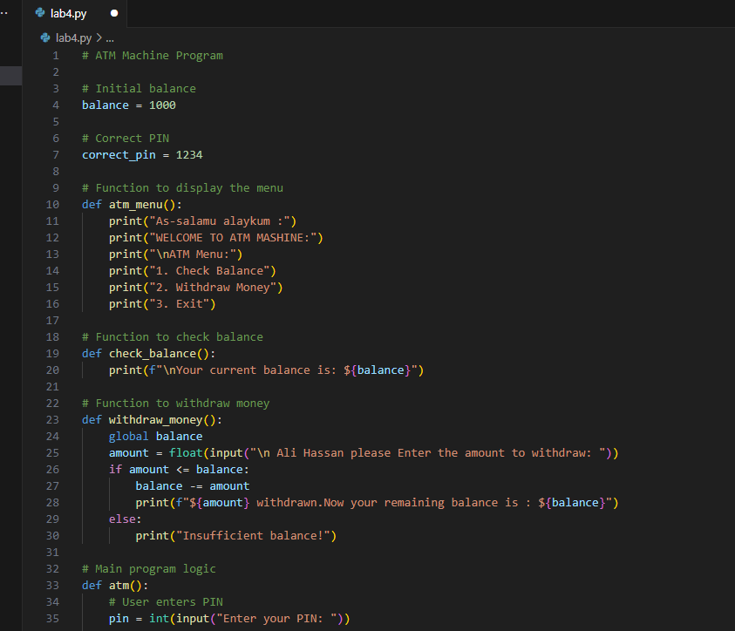

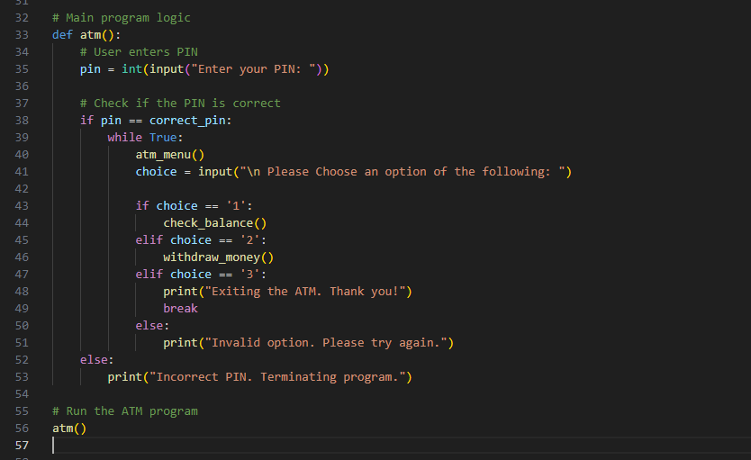

**Output: 1: Check balance:**

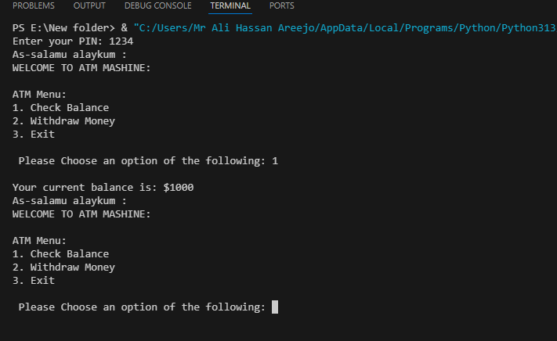

**2: Withdraw money:**

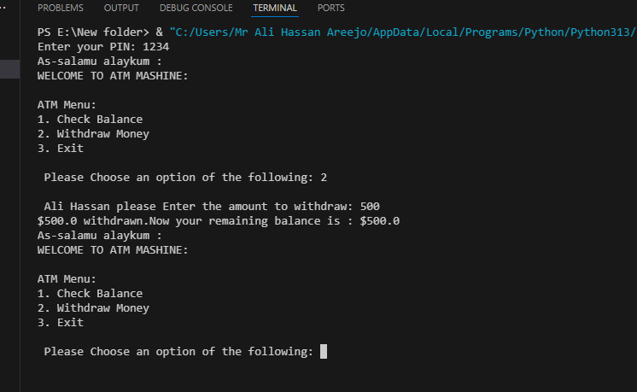

**3: Exit:**

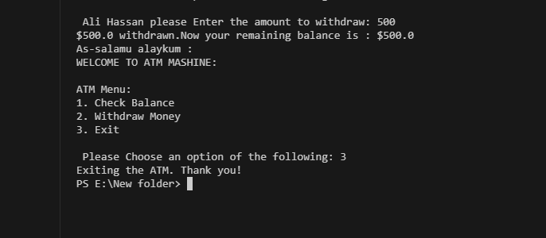

**Lab Task 2:**

Write a program that asks the user to enter a **username** and **password**.

* The correct username should be "admin" and the correct password should be the **numeric value** 12345.
* If both the username and password are correct, the program should display "Login Successful!".
* If the username is incorrect, display "Incorrect username".
* If the password is incorrect, display "Incorrect password".

**Code:**

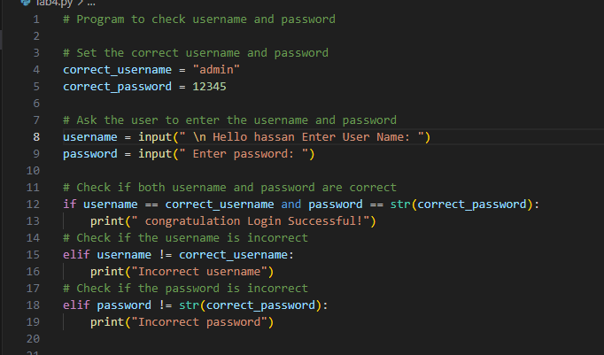

**output:**

**Login Successful!**

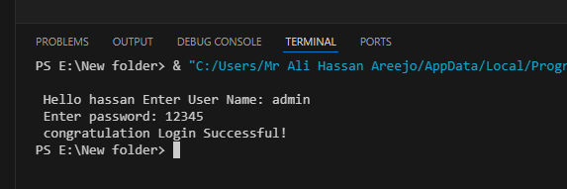

**Incorrect username:**

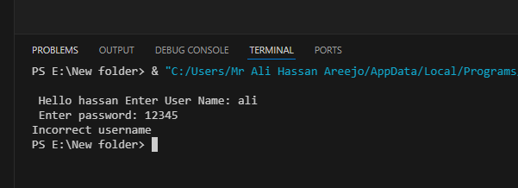

**Incorrect password:**

